Task 4 – High Value Transactions (Informatica IICS)

Objective
Load only transactions where NET_AMOUNT > 500.

Source Files
1. Clean_sales_records.csv
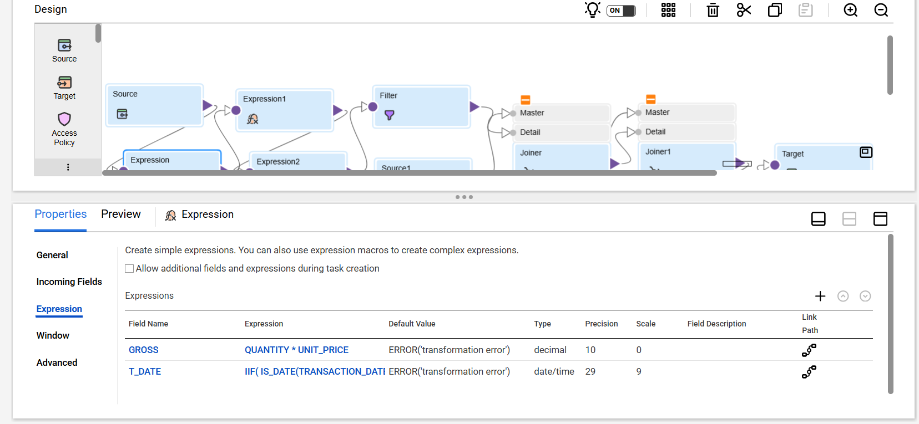
2. Customer Master
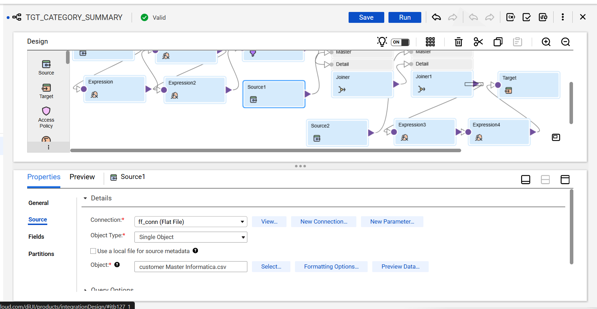
3. Product Master
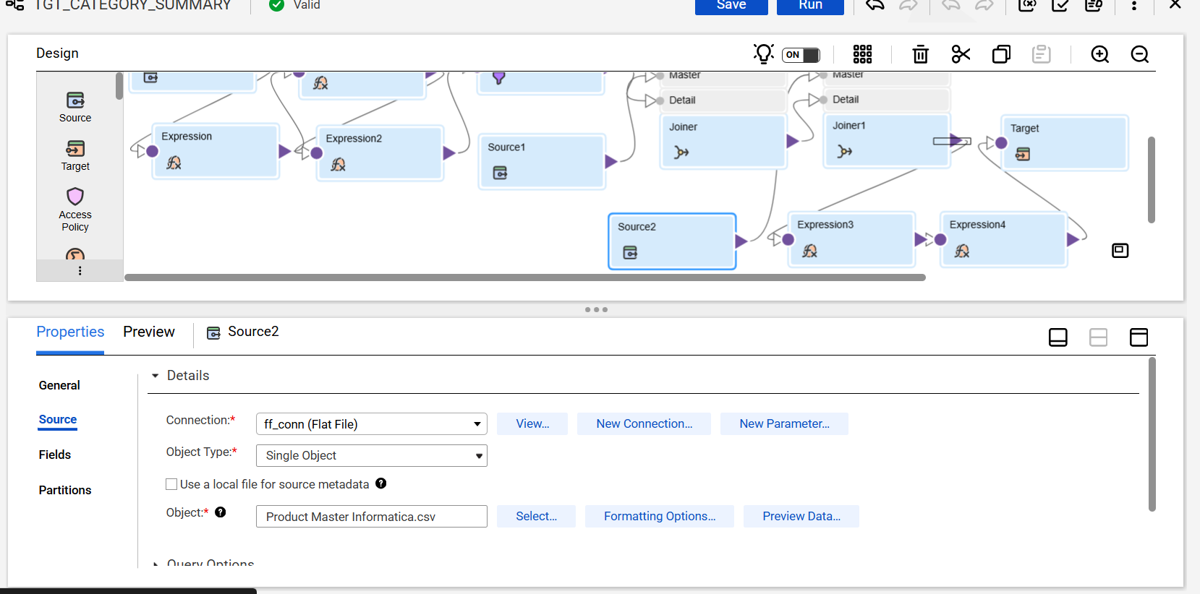

Mapping Flow
Source → Expression (Type Conversion & Gross) → Expression (Discount) → Expression (Net Amount) → Filter (NET_AMOUNT > 500) → Join Customer → Join Product → Target
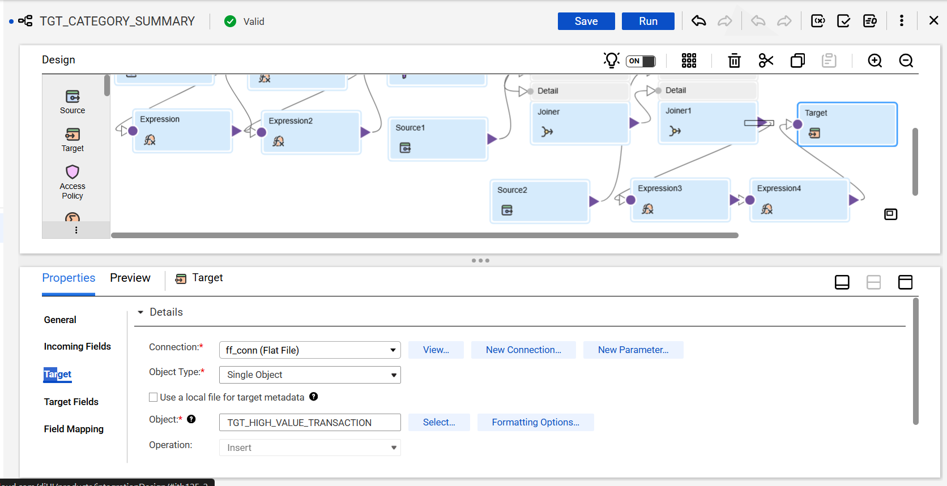

EXPRESSION LOGIC
1. Convert Quantity
QTY_NUM = IIF(ISNULL(QUANTITY) OR QUANTITY = '', 0, TO_INTEGER(QUANTITY))
2. Convert Unit Price
PRICE_NUM = IIF(ISNULL(UNIT_PRICE) OR UNIT_PRICE = '', 0, TO_DECIMAL(UNIT_PRICE))
3. Convert Discount Percent
DISC_NUM = IIF(ISNULL(DISCOUNT_PERCENT) OR DISCOUNT_PERCENT = '', 0, TO_DECIMAL(DISCOUNT_PERCENT))

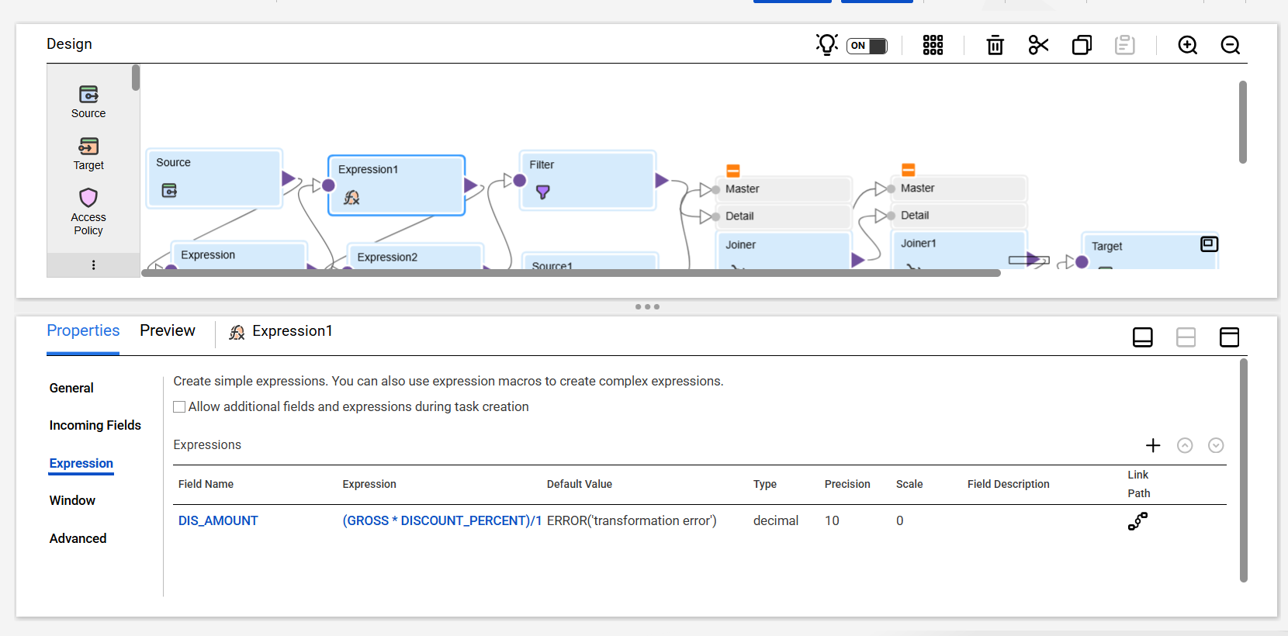
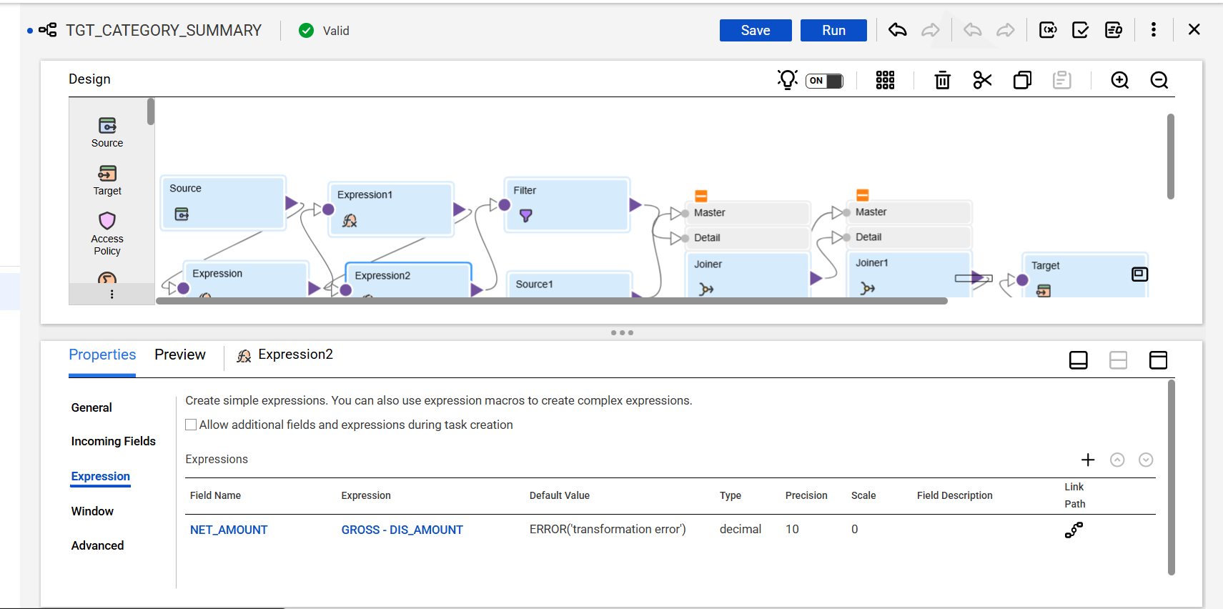
4. Gross Amount
GROSS = QTY_NUM * PRICE_NUM
5. Discount Amount
DIS_AMOUNT = (GROSS * DISC_NUM) / 100
6. Net Amount
NET_AMOUNT = GROSS - DIS_AMOUNT

Filter Condition
NET_AMOUNT > 500


Join Conditions
Customer Join: CUSTOMER_ID = INC_CUSTOMER_ID
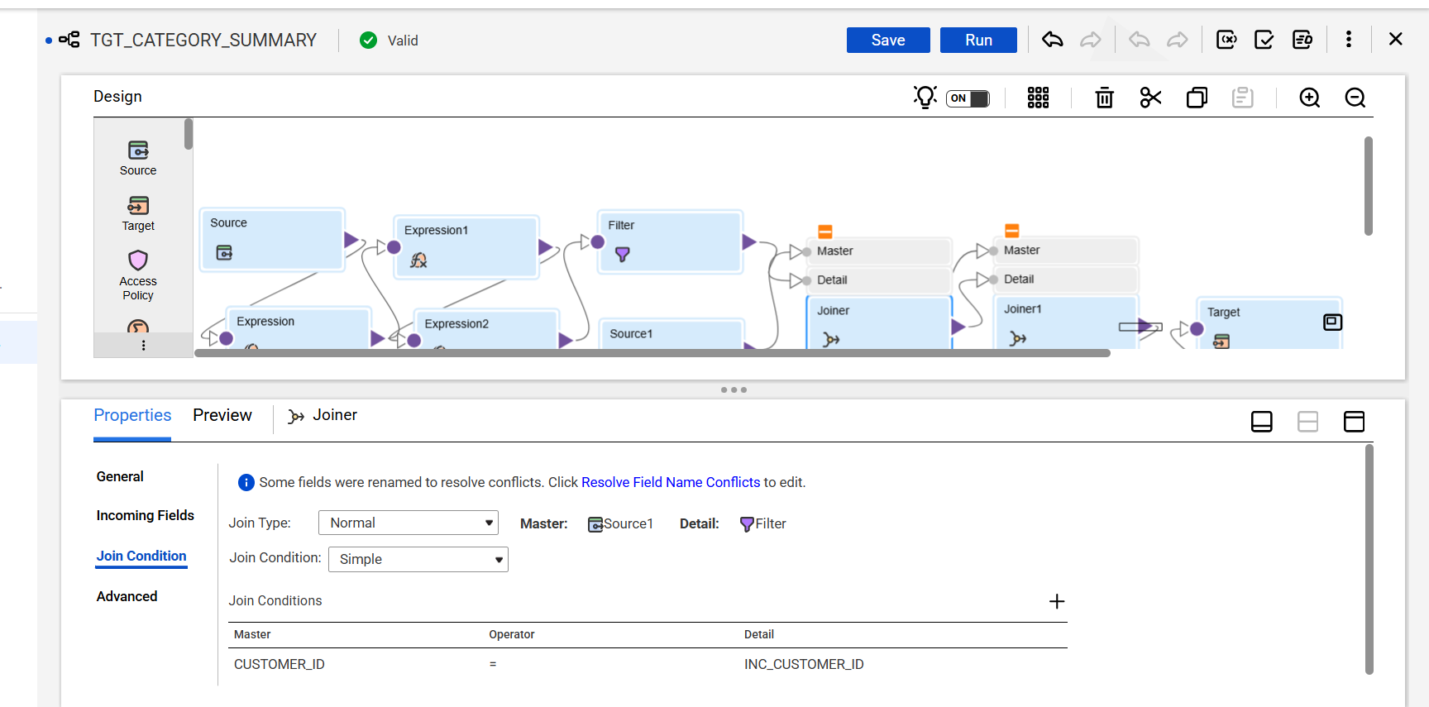
Product Join: PRODUCT_ID = INC_PRODUCT_ID
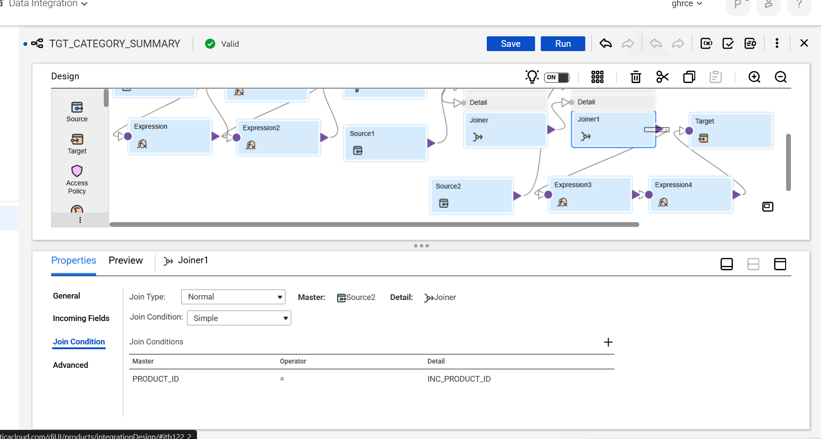

Target Table
TGT_HIGH_VALUE_TRANSACTION
Fields: TRANSACTION_ID, TRANSACTION_DATE, CUSTOMER_NAME, PRODUCT_NAME, NET_AMOUNT
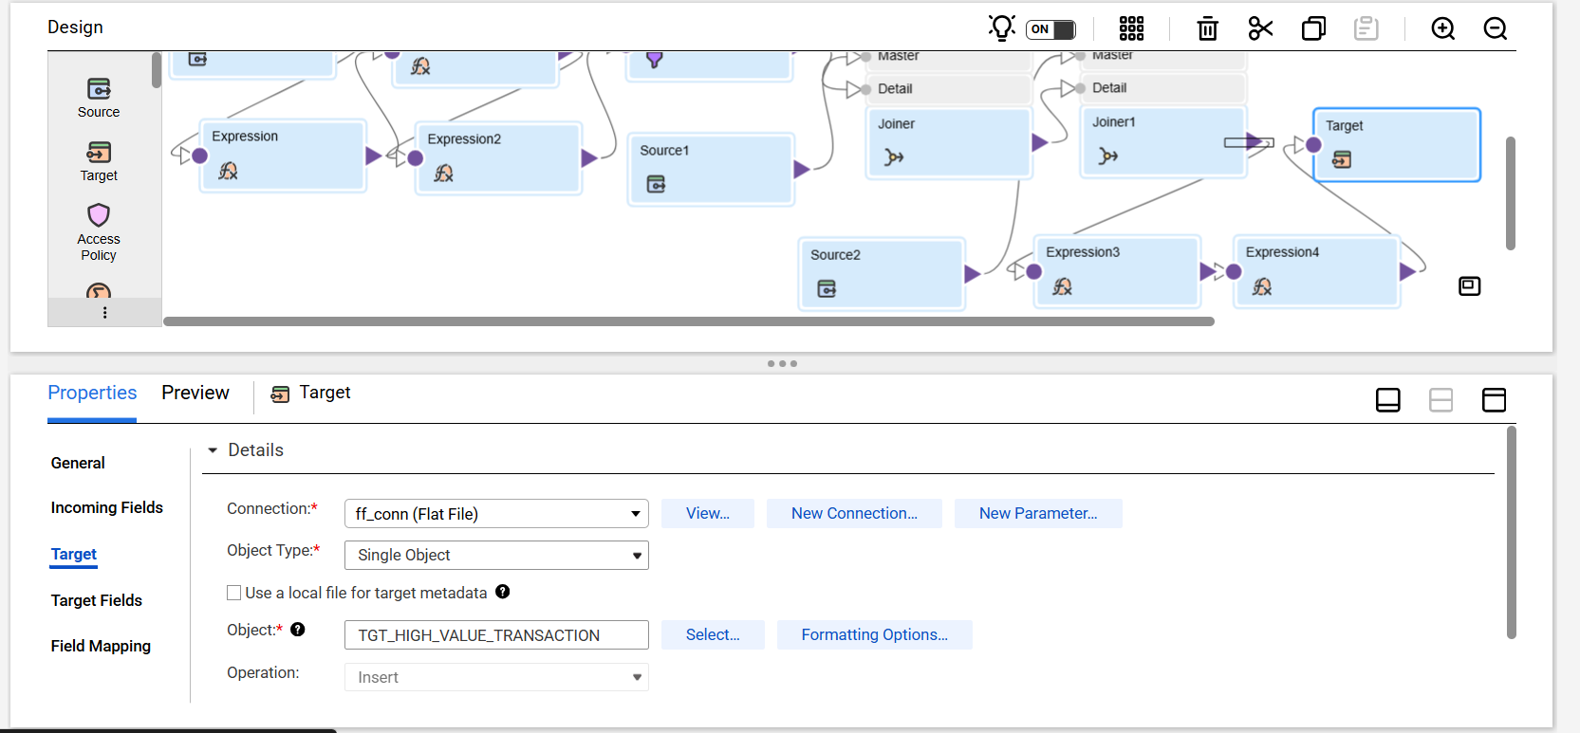

Expected Output
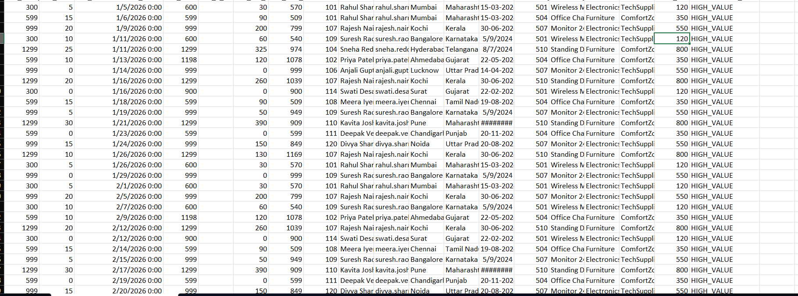
transactions where Net Amount is greater than 500.

Explanation
In this mapping, I converted string fields to numeric using Expression transformation, calculated Gross, Discount and Net Amount, filtered records where Net Amount > 500, joined Customer and Product master data, and loaded high value transactions into the target.

